Leetcode_402_RemoveKDigits_移除K个数字

# Leetcode_402_RemoveKDigits_移除K个数字

## 题目介绍

* 难度：Medium

* https://leetcode.com/problems/remove-k-digits/description/

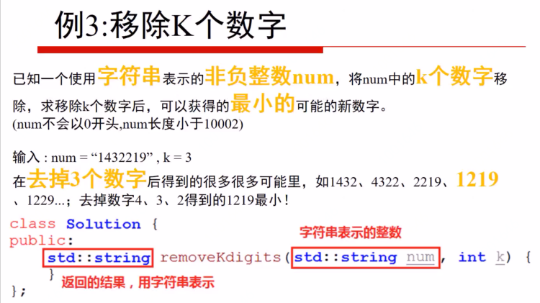

* Given a non-negative integer num represented as a string,

* remove k digits from the number so that the new number is the smallest possible.

* Note:

* The length of num is less than 10002 and will be ≥ k.

* The given num does not contain any leading zero.

* Example 1:

* Input: num = "1432219", k = 3

* Output: "1219"

* Explanation: Remove the three digits 4, 3, and 2 to form the new number 1219 which is the smallest.

* Example 2:

* Input: num = "10200", k = 1

* Output: "200"

* Explanation: Remove the leading 1 and the number is 200. Note that the output must not contain leading zeroes.

* Example 3:

* Input: num = "10", k = 2

* Output: "0"

* Explanation: Remove all the digits from the number and it is left with nothing which is 0.

## 思路分析

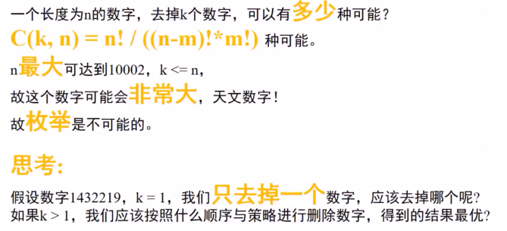

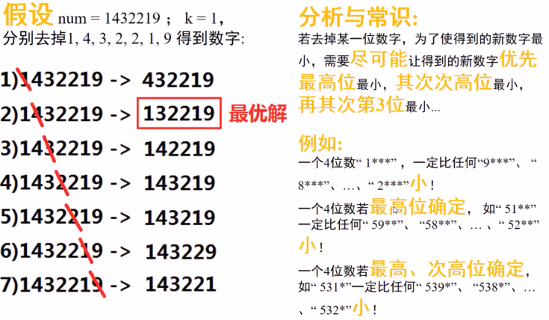

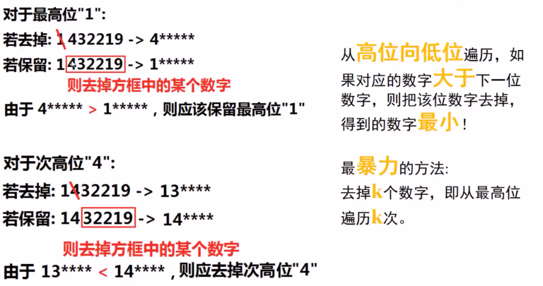

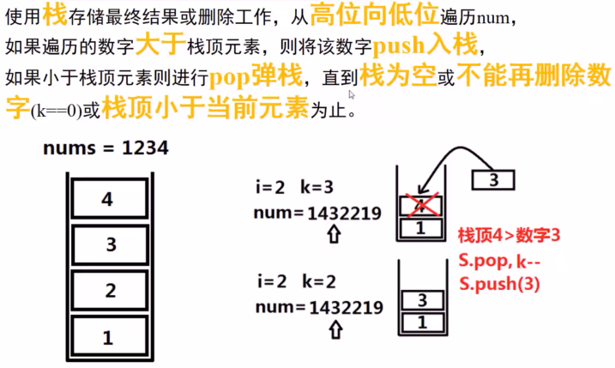

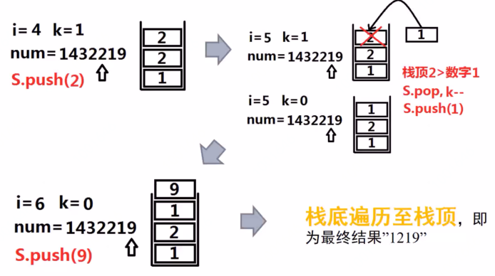

**最关键的三个问题：**

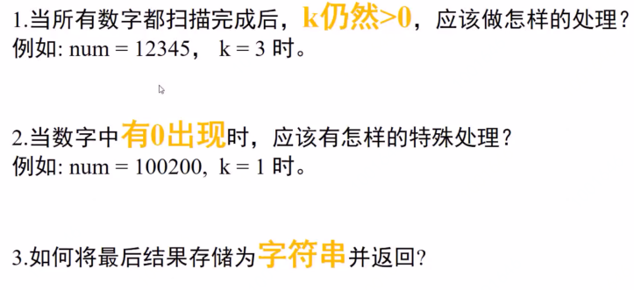

问题1：当扫描完毕，k仍然大于0，此时需要再重新扫描一遍；

利用双端队列实现。

问题2：0不能作为开头。

问题3：利用双端队列的特点从另一端拼接输出即可。

## Java代码